**Sequence Diagram:**

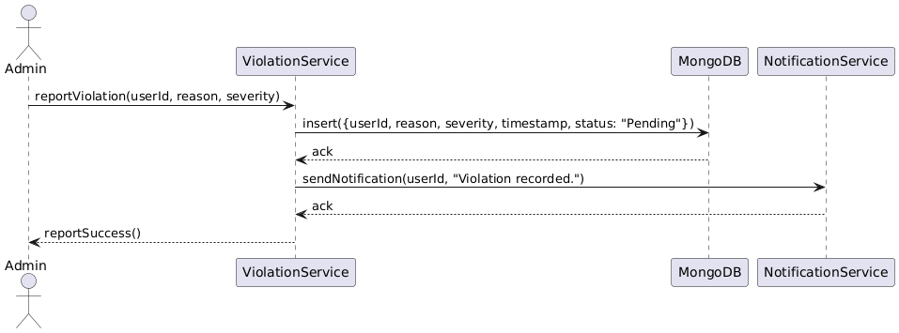

**Class diagram:**

**State Diagram:**

**ERD:**

**Functional Requirements**

1. The system shall allow an admin or moderator to report a user violation.
2. The system shall store violation reports in MongoDB with timestamps
3. The system shall allow viewing all violations for a user.
4. The system shall notify the user when a violation is recorded.
5. The system shall allow admins to take actions like warn, suspend, or ban users based on violation severity.
6. The system shall log actions taken on any violation.
7. The system shall allow filtering violations by user ID, date, or status.
8. The system shall prevent unauthorized users from accessing violation records.

**Non-Functional Requirements**

1. The system should respond to violation queries within 2 seconds.
2. The system shall be available 99.5% of the time.
3. MongoDB must ensure ACID compliance for all violation record updates.
4. Date must be encrypted both in-transit and at rest.
5. The system must support up to 10,000 violation reports without performance degradation.